Impington & Witchford Adult Learning

How to Register & Book Online

These instructions are for those who already have a membership account. If you have not registered for online booking, you will need to register for this service before making a booking / payment.

If you already go to Impington Sports Centre or have used it in the past, you may already be on their system. Please contact the Adult Learning Office on 01223 200411 or by email (adultlearning@living.tmet.org.uk) if you are unsure if you have a membership account or not.

If you are using a mobile phone or iPad, you may not be able to view all the options. You will need to switch your device to view full website and try again.

Step 1 – Reset Password
Go to the Impington Sports Centre website:

https://www.impington.cambs.sch.uk/impingtonsportscentre

Click on Members Area

You will now see the Account Login screen. Enter your email address. (If it says “invalid user name”, please contact the Office for assistance.)

Click Reset My Password.

Enter your email address again and click on Submit.

You will now receive an email from noreply@legendware.co.uk

Click on reset my password.

Step 2 – Registration
Once you have created a new password, you will be returned to the Account Login screen.
Enter email and password. Click on REGISTER AND

Click here

Enter email and password, tick T & Cs. Please note that these relate to the Sports Centre. For Adult Learning T & Cs, see https://www.impington.cambs.sch.uk/page/?title=General+Information&pid=30

click on Register.

Step 3 – How to Pay for an Allocated Place
You will now see the Welcome screen.
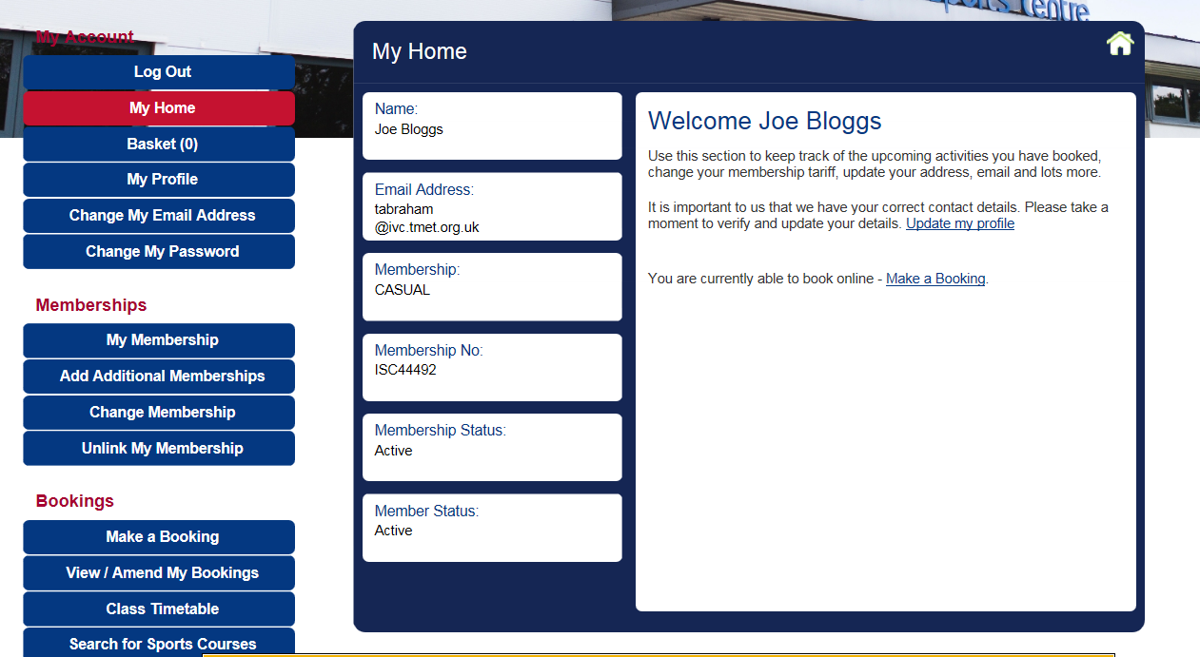
Click on
Search for Sports Courses

Enter the name of the course you want to book in the course search. Example – Strictly Dance Workout

Click Search

You will then see the results of your search. Click on your chosen course.

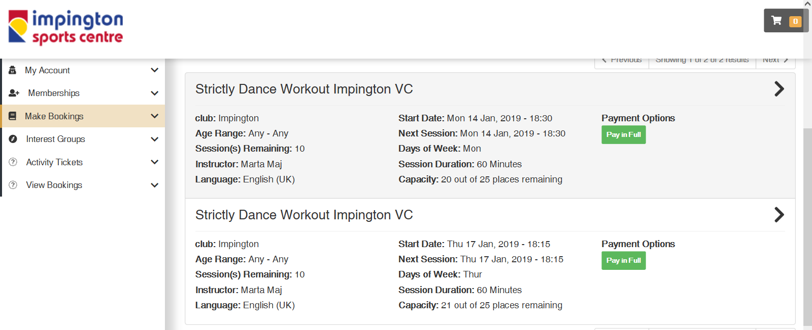

You will then be asked to pay for your course in full. Once you have paid online, you will receive an email confirming payment.

Please note, this is not a confirmation of the course running.

Adult Learning will notify you direct by email if the course is running or cancelled.

